Happy Street sample test (units 3 and 4)
- Odgovori sa Yes, it is ili No, it isn’t
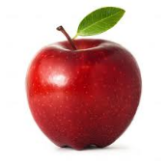  Is it a banana?  ____________ |   Is it a doll?  ____________ | 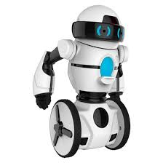  Is it a robot?  ____________ | 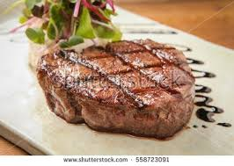  Is it a steak?  ____________ | 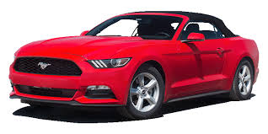  Is it a lorry?  ___________

- Napiši reči za date slike
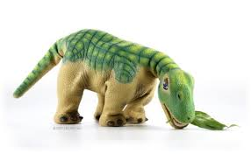  ______________ | 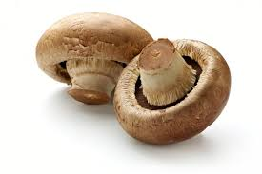  ______________ | 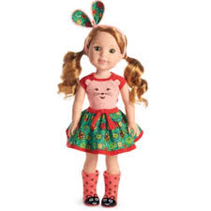  ______________ | 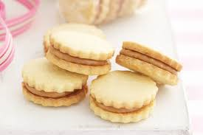  ______________ | 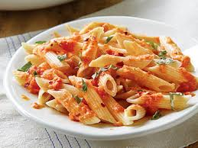  ______________
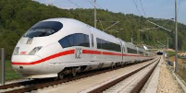  ______________ | 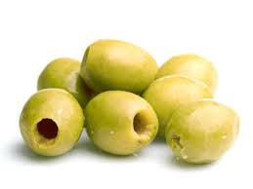  ______________ | 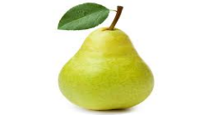  ______________ |   ______________ | 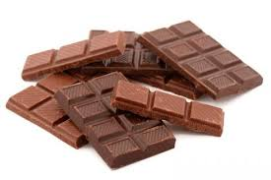  ______________

- Napiši A ili AN
____ book ____ orange ____ pencil ____ ice cream ____ pepper
____ plane ____ cat ____ dog ____ apple ____ robot

- Popuni tabelu datim rečima
five peppers pizza blue car eight yellow doll four pasta
TOYS | FOOD | COLORS | NUMBERS

- Koristeći date reči I slike napiši rečenice koje počinju sa I like ili I don’t like.
mushrooms olives steak peppers bananas pasta pears biscuits oranges apples


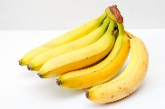

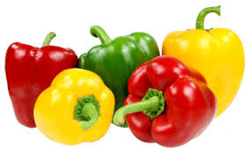
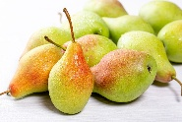
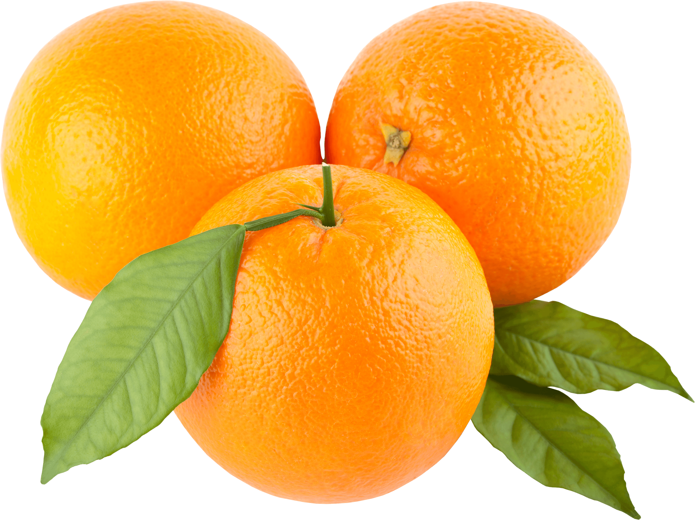
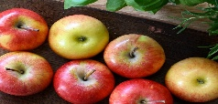
- Dopuni rečenice datim rečima
don’t | blast | can | around | are
friend | many | this | picture | everything
- Red robot turn _______________!
- _______________ I have ten bananas, please?
- What’s _________________? Oh, it’s a robot!
- Dear _______________, thank you for your e-mail.
- Look Colin! _______________ is white.
- I _______________ like cakes. Yuck!!!
- 10,9,8,7,6,5,4,3,2,1 _______________ off!
- Here you _______________!
- Sorry, how _______________?
- Here’s a _______________ of me and my mom at a pizza restaurant.

