Unit 5 and 6 Sample Test

1. THERE IS or THERE ARE
2. _______________ a bike in the garden.
3. _______________ ten boys in our class.
4. _______________ a lot of bananas on the table.
5. _______________ one apple in my lunch box.
6. _______________ many books on the desk.
7. CAN or CAN’T

|  |  |  |  |  |
| --- | --- | --- | --- | --- |
| sing | draw | write | ride | drive |



1. Jack / X ___________________________________________ a horse.
2. I /  √ _______________________________________________ a song.
3. My sister / 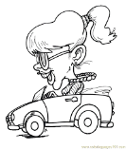 X ________________________________________ a car.
4. We / 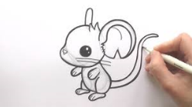 √ __________________________________________ .
5. She / 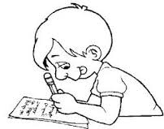 √ __________________________________________ a letter.
6. Short answers
7. Can you read? √ ______________________________________________
8. Are there two oranges on the table? X______________________________________________
9. Is there a cat under the chair? √ ______________________________________________
10. Have you got a sister?_ √ _____________________________________________
11. Has Mickey got a brother? √ ______________________________________________
12. Does she like chocolate? X______________________________________________
13. Is Anna at school? X______________________________________________
14. Can Mut fly? X __________________________________________________
15. Translate
16. Autobuska stanica - ___________________________
17. Muzej - _____________________________________
18. Banka - _____________________________________
19. Kafić - _____________________________________
20. Crkva - _____________________________________
21. Bioskop - ___________________________________
22. Park - ______________________________________
23. Pošta - _____________________________________
24. Prodavnica - ________________________________
25. Trg - ______________________________________
26. Present Continuous
27. My parents _____________________ (look) for a new house.
28. We _______________________ (cut) some pictures for our project.
29. Jack ______________________ (move) to America.
30. My friends ______________________ (play) football.
31. I ______________________ (tie) my shoes.
32. You _______________________ (not listen) to me.
33. _____________________ (Sally sleep) now?
34. I ____________________________ (not work) at the moment.
35. __________________________ (rain) at the moment?
36. I ________________________ (not do) anything now.
37. Present Simple or Present Continuous
38. I usually _________________________(go) to school by bus, but now I _________________________(go) by car.
39. We often _________________________(play) football on Monday, but today we _________________________(play) on a Wednesday.
40. Sammy sometimes _________________________(speak) German. Now his brother from Germany is with Sammy and they _________________________(talk) in German together.
41. Dad _________________________(fix) the car at the moment. He usually _________________________(take) the car to the mechanic.
42. I usually _________________________(eat) fish for lunch, but at the moment I _________________________(eat) a burger.
43. Look at the picture. Complete the sentences with these prepositions:

IN, ON, UNDER, BETWEEN, BEHIND, IN FRONT OF, NEXT TO

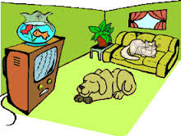

1. There are two fish _____________________________ the TV.
2. There is a dog _____________________________ the TV and the sofa.
3. There is a plant _____________________________ the sofa.
4. There is a sofa _____________________________ the window.
5. There are two fish _____________________________ the water.
6. UNIT 5 and 6, LESSONS: A, B, C, D

|  |  |  |  |  |
| --- | --- | --- | --- | --- |
| poster | shower | speak | smart | downstairs |
| sofa | supermarket | dream | teddy bear | clever |

1. We are making a _____________________.

2. I can fly. Oh, it’s just a __________________.

3. I want to go to the _________________ and buy some food.

4. There is a _______________ in my sitting room. I love to sit on it.

5. Mickey and Millie are wearing _____________________ clothes now because they are going out.

6. My _______________ is on the bed. He is old, but I love him.

7. There is a kitchen _______________.

8. There is a _______________ in her bathroom.

9. Can you _______________ English?

1. Only ______________________ people can see the King’s magic clothes.